QUANTUM FOURIER TRANSFORM:-

In many cases, its useful to transform one problem to another whose solution is known.

Discrete Fourier Transform:-

This takes an input a vector of complex numbers x₀,x₁,.... x_{N-1}, where length N is a fixed parameter, and outputs another vector of fixed length y₀, y₁, y₂,.... y_{N-1}, defined by-

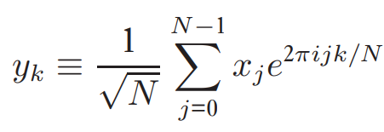

Quantum Fourier Transform:-

Its a similar transform. QFT on an orthonormal basis-

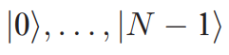

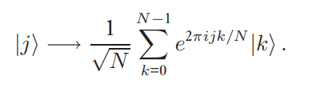
is defined as a linear operator with following action on the basis states-

QFT is a part of many algorithms -

a) Shor’s algorithm

b) Quantum phase estimation algorithm

c) Hidden subgroup problem

The QFT can be equivalently viewed as a unitary matrix acting on quantum state vectors, where the unitary matrix F_{N} is given by-

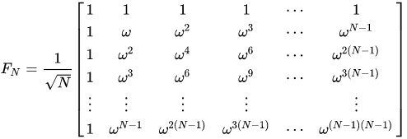
where omega is the Nth root of unity.

Here N is always multiple of 2.

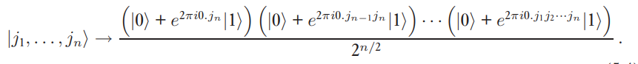
With a little algebra, the Quantum Fourier transform can be given the following representation -

This representation helps us to create a Quantum circuit for QFT.

Lets loot at the quantum gate R_{k}. It represents the unitart transformation-

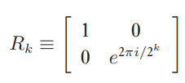

This represents rotation of the computational basis |1> .

Look at the above matrix, and the representation of QFT. You can notice some similarities.

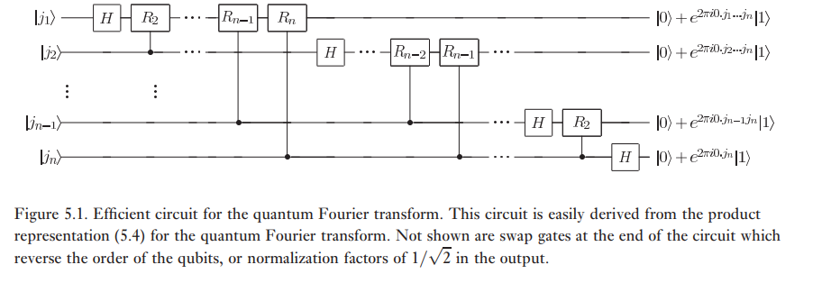

This is the circuit for the QFT.

